**README-**

**Note:**

The compilation and deployment sections are provided with instructions for Linux/MAC command line. For windows, please use respective windows command line options.

**Deployment Steps:**

Execute the following in command line.

1. Extract Archive

2. Change to “ScalyrApp” directory

cd Fusion

**Prerequisites:**

**Install Node.js**

**To Build the project:**

1. Install Node packages:

npm install

2. Install Bower:

npm install bower

3. Install Bower packages:

bower install

**To Run the project:**

grunt serve --force

**Working of the Application.**

List of all the doctors- I have built a JSON file which contains all the list of the doctors.

There are 4 attributes of a doctor which I have taken into consideration-

Doctor’s Name, Location, Specialty and a Score or (Ratings).

The original list is not sorted.

**Case:1**

Whenever you hover on any Specialty you will see all similar Doctors containing that specialty.

Below we can see that whenever we hover on Neurology aside we can see that we can see similar doctors in Neurology domain.

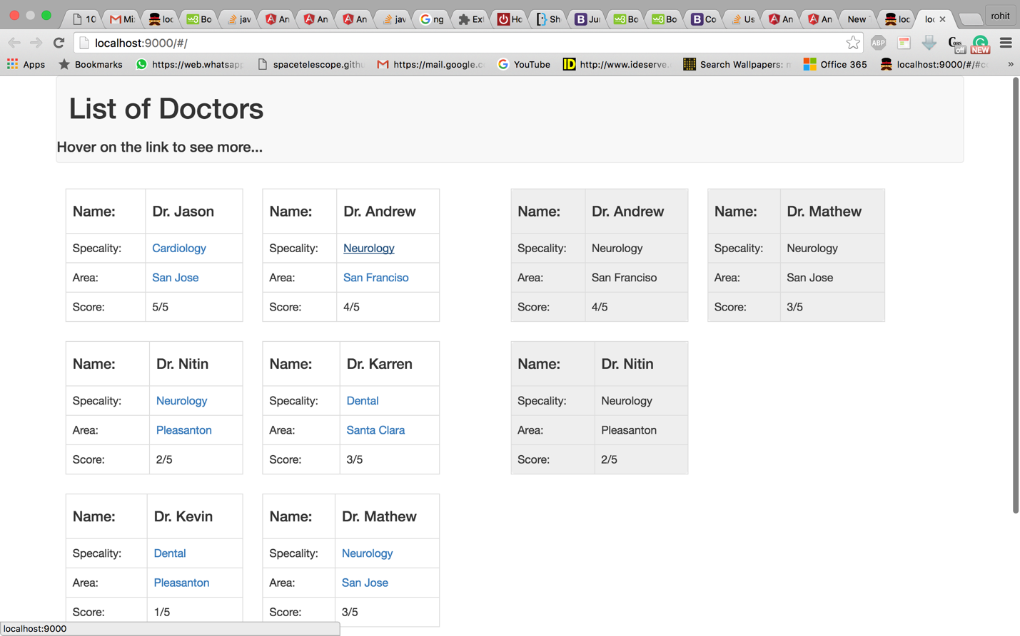

**Case:2**

**Whenever you hover on any Place you will see all Doctors from that locality.**

Below we can see that whenever we hover on Pleasanton, aside we can see that we can see similar doctors from Pleasanton location.

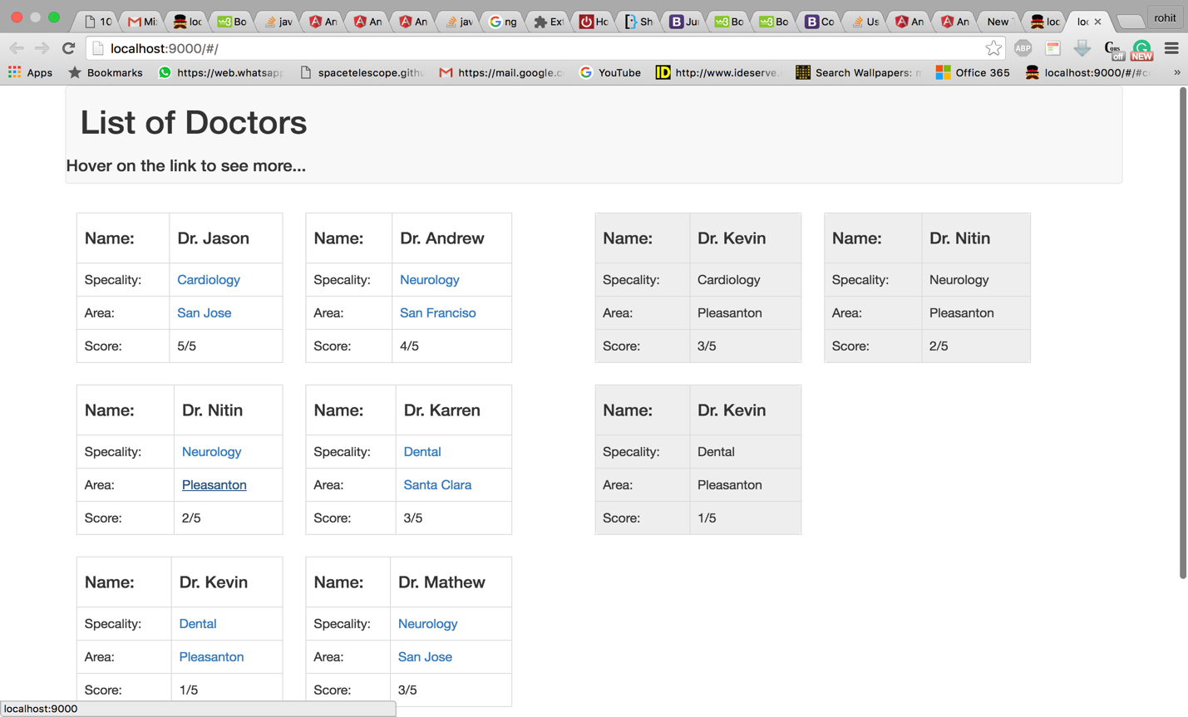

**The Doctors are ordered with respect to their score. From highest to lowest.**